**Database name = myshop**

**Table 1=author**

INSERT INTO author VALUES (1,"Nimal",1,0);

INSERT INTO author VALUES (2,"kamal",1,0);

INSERT INTO author VALUES (3,"Sunil",1,0);

INSERT INTO author VALUES (4,"Kumara",1,0);

INSERT INTO author VALUES (5,"muthuhari",1,0);

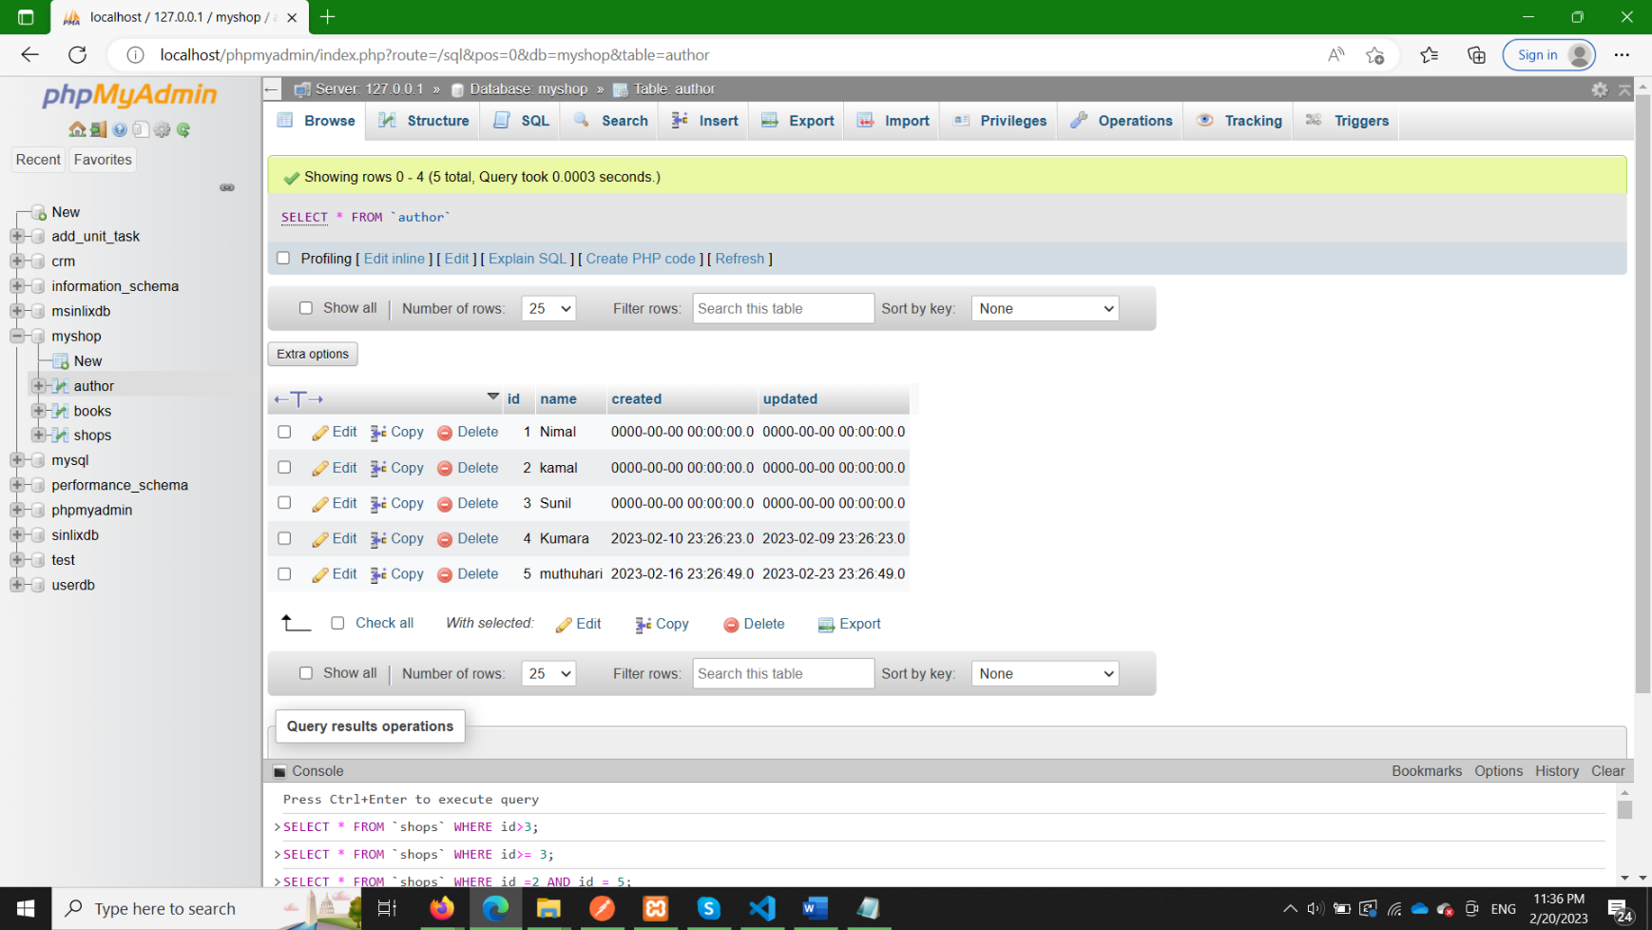

**Table 2= books**

INSERT INTO books VALUES (1,1,"Yuganthaya",1,0);

INSERT INTO books VALUES (2,2,"Gamperaliya",1,0);

INSERT INTO books VALUES (3,3,"Hathpana",1,0);

INSERT INTO books VALUES (4,3,"Kavi potha",1,0);

INSERT INTO books VALUES (4,3,"AMMA",1,0);

INSERT INTO books VALUES (4,3,"Viragaya",1,0);

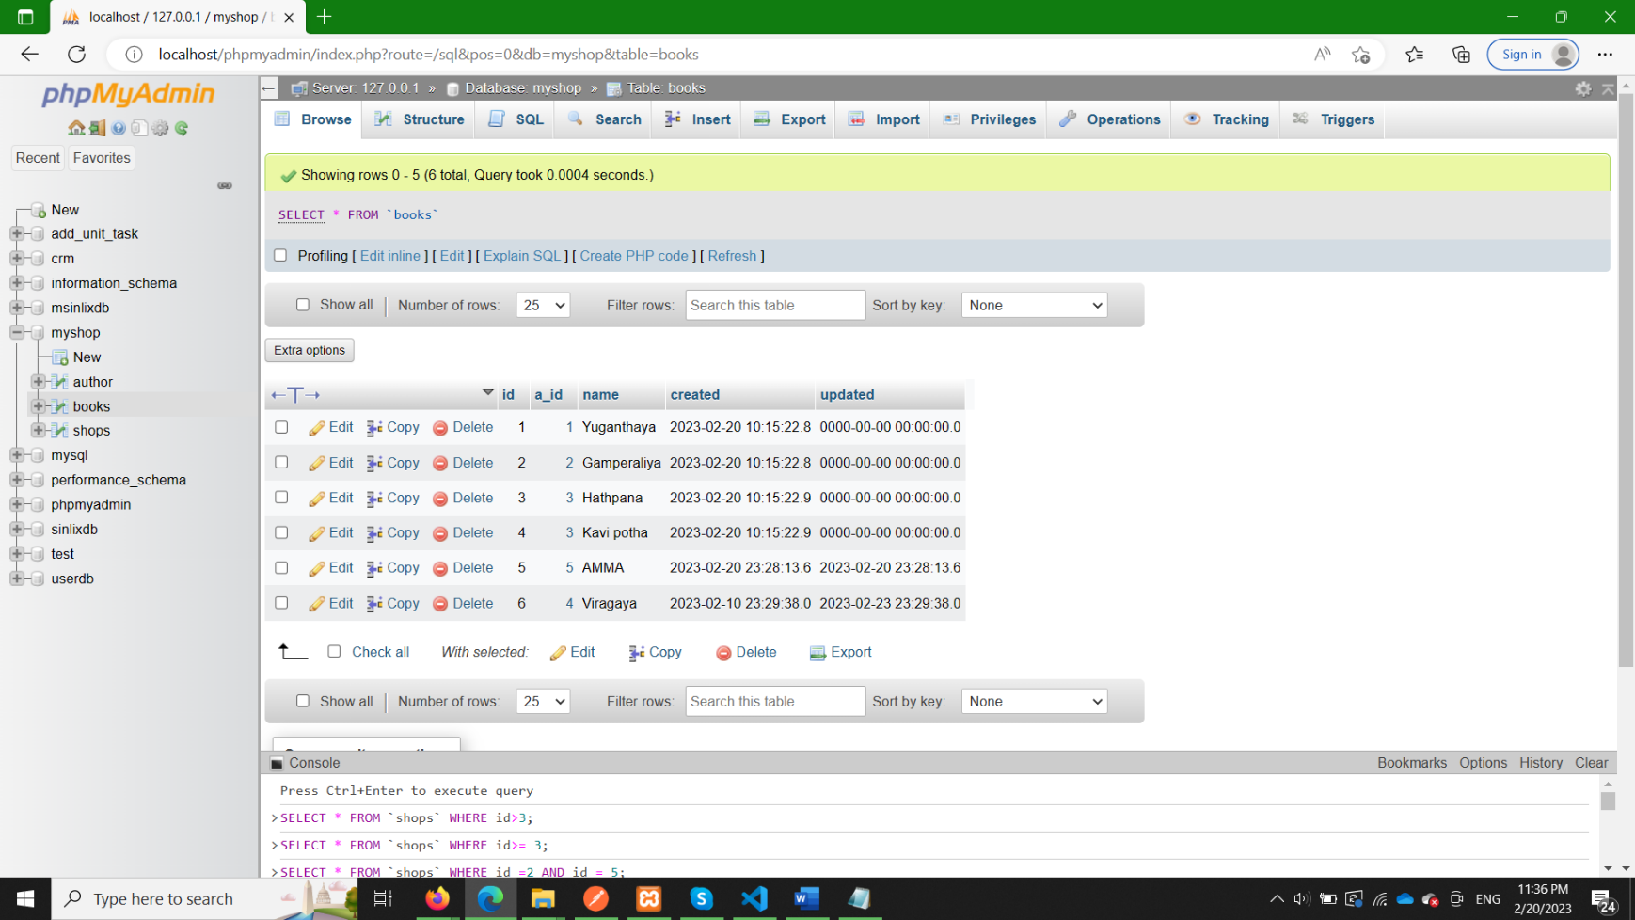

**Table 3=shops**

INSERT INTO shops VALUES (1,1,25,1,0);

INSERT INTO shops VALUES (2,2,15,1,0);

INSERT INTO shops VALUES (3,3,35,1,0);

INSERT INTO shops VALUES (4,3,155,1,0);

INSERT INTO shops VALUES (5,3,35,1,0);

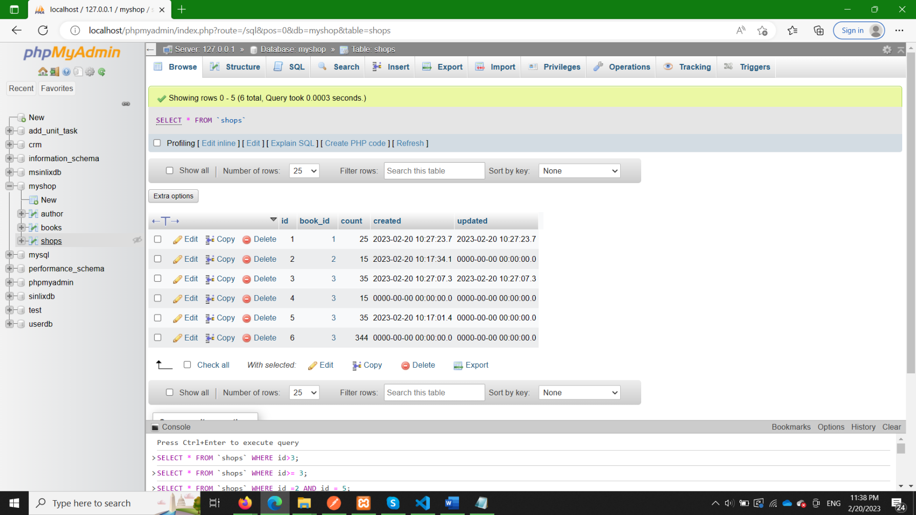INSERT INTO shops VALUES (6,3,344,1,0);